**Data Overview**

* This dataset is a subset of Yelp and has information about businesses across 8 metropolitan areas in the USA and Canada.
* The original data is shared by Yelp as JSON files.
* The five JSON files are business, review, user, tip and checkin.
* The JSON files are stored in the database for easy retrieval of data.

**Analysis and Findings**

* Out of 150k businesses, 35k are restaurants business and are open.
* ﻿﻿Table showing distribution of business success metrics (review count and average rating):

**Highest Rating Highest Review Count**

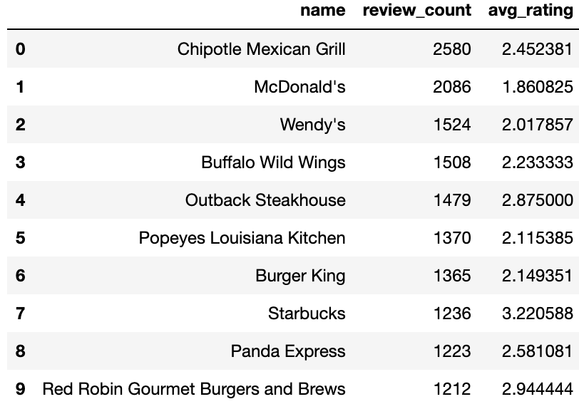

* Higher ratings do not guarantee a higher review count, or vice versa.
* Success of Restaurants is not solely determined by ratings or review counts.
* Review count reflects user engagement but not necessarily overall customer satisfaction or business performance.

**Do restaurants with higher engagement tend to have higher ratings?**

* Data shows a general increase in average review, check-in, and tip counts as ratings improve from 1 to 4 stars.
* Restaurants rated 4 stars exhibit the highest engagement and shows a downward trend for rating above 4.
* The drop in engagement at 5.0 stars might suggest either a saturation point where fewer customers feel compelled to add their reviews, or a selectivity where only a small, satisfied audience frequents these establishments.

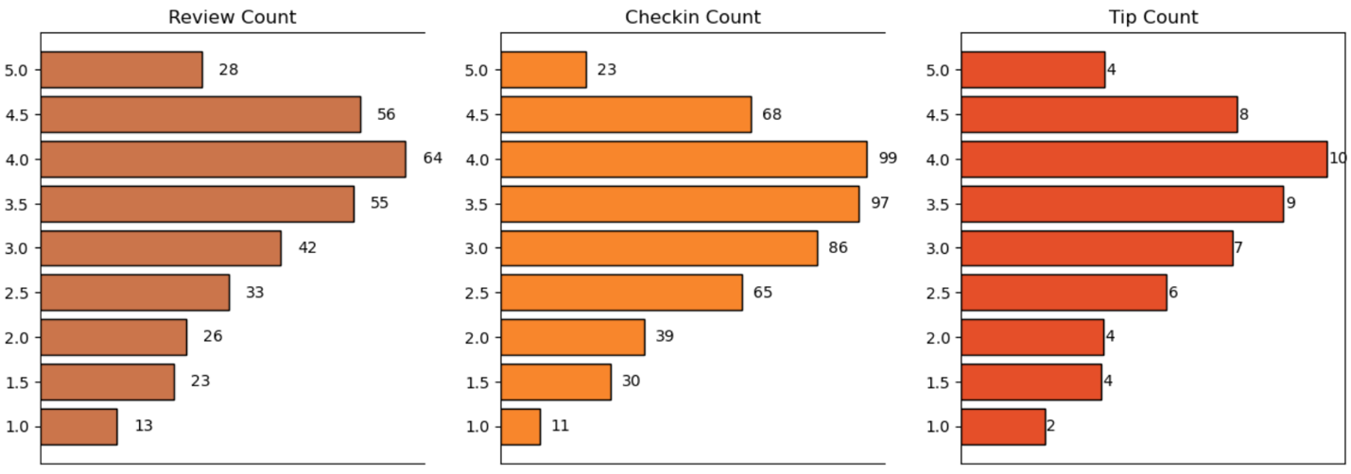

**Is there a correlation between the number of reviews, tips, and check-ins for a business?**

* These correlations suggest that user engagement across different platforms (reviews, tips, and check-ins) is interlinked; higher activity in one area tends to be associated with higher activity in others.
* Businesses should focus on strategies that boost all types of user engagement, as increases in one type of engagement are likely to drive increases in others, enhancing overall visibility and interaction with customers.

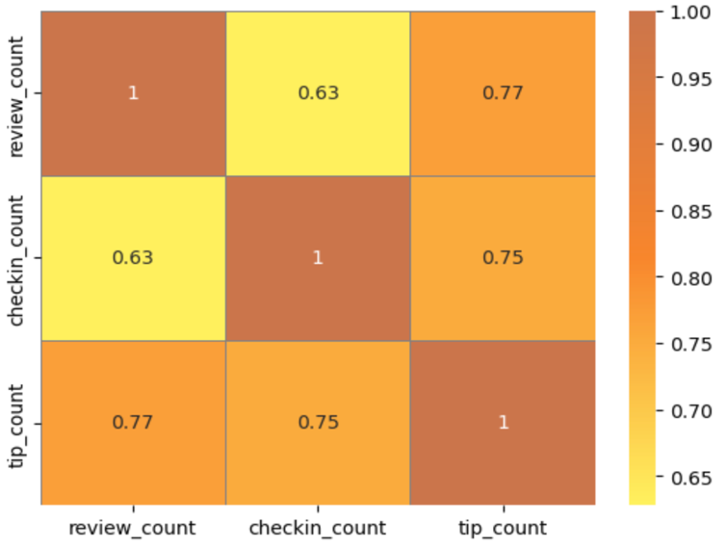

**Is there a difference in the user engagement between high-rated and low-rated businesses?**

* Data indicates a clear correlation between higher ratings and increased user engagement across reviews, tips, and check-ins.
* ﻿﻿This pattern underscores the importance of maintaining high service and quality standards, as these appear to drive more reviews, check-ins, and tips, which are critical metrics of customer engagement and satisfaction.

**How do the success metrics of restaurants vary across different states and cities?**

* Philadelphia emerges as the top city with the highest success score, indicating a combination of high ratings and active user engagement.
* Following Philadelphia, Tampa, Indianapolis, and Tucson rank among the top cities with significant success scores, suggesting thriving restaurant scenes in these areas.

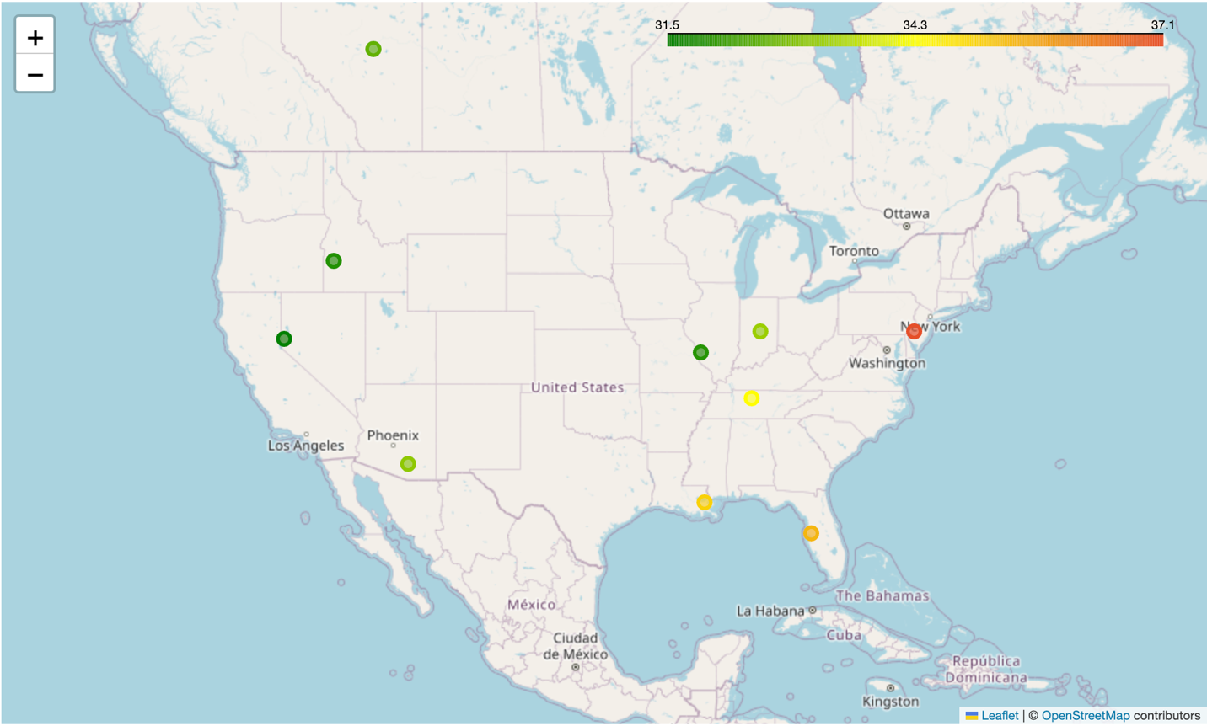

**Are there any patterns in user engagement over time for successful businesses compared to less successful ones?**

* Successful businesses, particularly those with higher ratings (above 3.5), exhibit consistent and possibly increasing user engagement over time.
* High rated restaurants maintain a steady or growing level of user engagement over time, reflecting ongoing customer interest and satisfaction.

**How does the sentiment of reviews and tips (useful, funny, cool) correlate with the success metrics of restaurants?**

* "useful", "funny" and "cool" are attributes associated with user reviews. They represent the feedback provided by users about the usefulness, humor, or coolness of a particular review.
* Higher counts of useful, funny, and cool reviews suggest greater user engagement and satisfaction, which are key factors contributing to a restaurant's success.

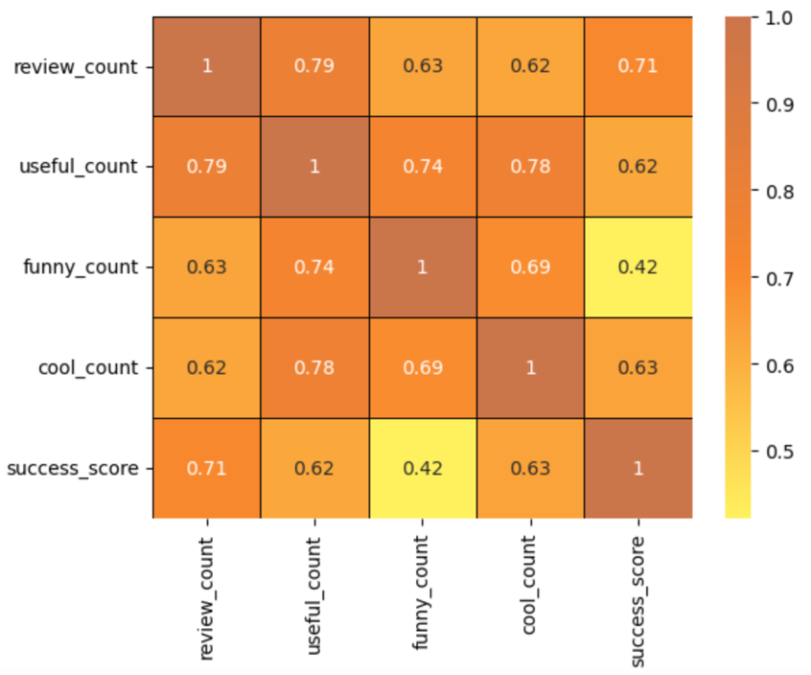

**Is there any difference in engagement of elite users and non-elite users?**

* Elite users are individuals who have been recognized and awarded the "Elite" status by Yelp for their active and high-quality contributions.
* Elite users, despite being significantly fewer in number, contribute a substantial proportion of the total review count compared to non-elite users.
* ﻿﻿Establishing a positive relationship with elite users can lead to repeat visits and loyalty, as they are more likely to continue supporting businesses, they have had good experiences with.

**Busiest Hours**

* The busiest hours for restaurants, based on user engagement, span from 4 pm to 1 am.
* Knowing the peak hours allows businesses to optimize their staffing levels and resource allocation during these times to ensure efficient operations and quality service delivery.
* The concentration of user engagement during the evening and night hours suggests a higher demand for dining out during these times, potentially driven by factors such as work schedules, social gatherings, and leisure activities.

**Recommendations**

* Utilizing insights from the analysis of various metrics such as user engagement, sentiment of reviews, peak hours, and the impact of elite users, businesses can make informed decisions to drive success.
* Collaborating with elite users and leveraging their influence can amplify promotional efforts, increase brand awareness, and drive customer acquisition.
* Businesses can adjust their operating hours or introduce special promotions to capitalize on the increased demand during peak hours.
* Less successful businesses may need to focus on strategies to enhance user engagement over time, such as improving service quality, responding to customer feedback.
* ﻿﻿Cities with high success scores presents opportunities for restaurant chains to expand or invest further.